Elite Trampoline Academy
Athlete Clinic
“It is all about Trampoline”

October 28-29, 2017
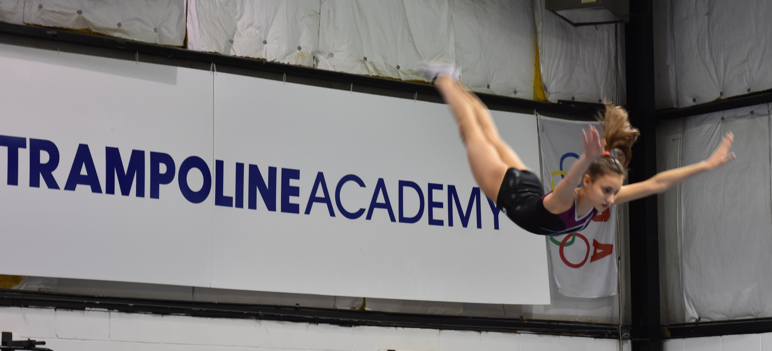

Clinicians:

Tatiana Kovaleva
1996,1998,199 World Trampoline Champion
1995,1997 European Trampoline Champion
USA National Coaching Staff
2012 Olympic Games USA Trampoline Coach
FIG Judge

Steven Gluckstein
USA National Team Member
2012 Olympian – London, England
5 times USA National Trampoline Champion
Silver Medalist at Pan Am Games 2015
Category 1 USA Trampoline Judge
Junior National Team Coach

Jeffrey Gluckstein
3 times USA National Champion
Silver Medalist at Pacific Rim 2016
USA National Team Member
Category 1 USA Trampoline Judge

Gym Address:
549 State Route 35
Middletown, NJ

ATTENTION
TRAMPOLINE, GYMNASTICS,
TUMBLING COACHES AND CLUB OWNERS

Coaches will have a chance to increase their knowledge of trampoline skills, their progressions, and the biomechanics of proper jumping.

This is a great opportunity for you and your athletes to learn proper trampoline technique that will help your athletes better their performance and future career.

You will have the opportunity to prepare your athletes for 2017 competitive season.

The clinicians can also help you make a compulsory and/or optional routine for your Senior, and Junior, and Youth Elite Athletes.

DO NOT MISS THIS AMAZING OPPORTUNITY TO EDUCATE YOURSELF AND YOUR COACHING STAFF!

Clinic Schedule

Saturday, October 28, 2017
11:00 p.m. – 1:00 p.m. Session 1
12:30 p.m. – 2:30 p.m. Session 2
30 min Break for clinicians
2:30 p.m. – 4:30 p.m. Session 3
4:00 p.m. – 6:00 p.m. Session 4
Sunday, October 29, 2016
8:30 a.m. – 10:30 a.m. Session 5
10:00 a.m. – 12:00 p.m. Session 6
12:00 p.m. - 2:30 p.m. Session 7

NOTES:

Registration begins immediately. It is important to register early because we will run on a “first come, first serve” basis.

It is very important that you state your arrival and departure schedules so that the clinic schedule can be made accordingly. You can mail this information to Tatiana Kovaleva at 549 Route 35, Red Bank, NJ 07701 or e-mail tatianakovaleva@elitetrampolineacademy.com.

The clinicians will place you in the appropriate session(s). They will try their best to work with you, but everyone may not have their exact desired times.

ATHLETE CLINIC REGISTRATION

Gym Name: _____________ Coach_______________________

Athlete Name: _______________ USAG #
_
Address:

City: State: Zip:

Gym Phone: _____________ Cell Phone: ________________________

E – Mail: ____________________________________

Trampoline Level: DD of Optional Routine:

Most Difficult Skill:

Skill looking to learn at the clinic:

Cost of Athlete Clinic: $140.00 (3 Sessions)
Preferred sessions: ___________________________________
Each additional session: $30.00

NO REFUNDS!!!

Checks payable to: Elite Trampoline Academy
549 Route 35
Red Bank, NJ 07701
732-747-4000
Credit Card Option Payment:

Type of card________________

Card Number ______________________________

Expiration Date_____________ CVD Code__________ Zip Code_______________

Participants will be responsible for their own accommodations:

Comfort Inn
750 State Route 35 South
Middletown, NJ 07748
(732) 671-3400

Courtyard Marriott
600 Hope Rd
Tinton Falls, NJ 07724
(732) 389-2100

Holiday Inn Hazlet
2870 Rte 35, Hazlet, NJ 07730
(732) 888-2000

