“It’s All About Trampoline” Clinic
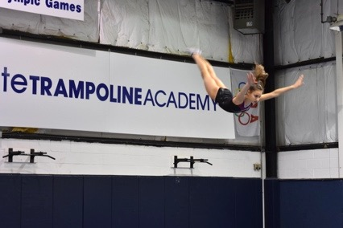
For Athletes, Coaches, and Judges
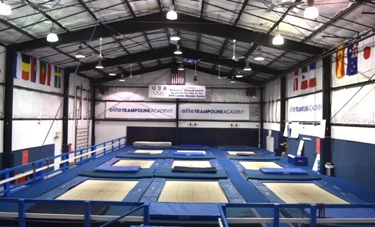
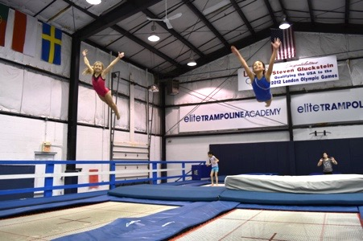
When: October 13-14, 2018

Where: Elite Trampoline Academy
549 Route 35
Middletown, NJ 07748
*40 miles from NYC
Includes 9 Competitive Trampolines, multiple spotting mats of various sizes, and spotting harness

Who: Athletes and coaches of all levels

What: Athletes will work with World Champions and Olympians to learn and progress their trampoline skills and routines through drills, progressions, spotting, lessons in biomechanics, and routine building! Athletes will also better prepare for the upcoming season, set new compulsories and optional routines.

The “All About Trampoline” Clinic is also a great learning experience for coaches to gain knowledge on progressions, drills, and helping athletes cope through fears and mental blocks.

Clinicians will also help you create a compulsory and/or optional routine for your Elite Athletes to optimize their total score for the 2018-2019 competition season.

Also, experience NYC in just an hour train ride, 40-minute boat ride, or 50-minute drive!

Schedule:
Saturday, October 13, 2018
12:00 p.m. – 2:00 p.m. Session 1
1:30 p.m. – 3:30 p.m. Session 2
3:30 p.m. – 5:30 p.m. Session 3
5:00 p.m. – 7:00 p.m. Session 4
Sunday, October 14, 2018
9:00 a.m. – 11:00 a.m. Session 5
10:30 a.m. – 12:30 p.m. Session 6
12:00 p.m. - 2:00 p.m. Session 7

Clinicians:
Tatiana Kovaleva Steven Gluckstein Jeffrey Gluckstein
1996, ’98, ’99 World Champion 2012 Olympian, 2016 Team Member 6 Time USA National Champion
1995 & 1997 European Champion US Jr. Nat’l Team Head Coach 2016 Pac Rim Silver Medalist
2012 Olympic Games USA Coach 10 Time USA National Champion 6x World Champ Team Member
USA National Coaching Staff 2nd Place 2015 Pan Am Games Category 1 USA TR Judge
Category 2 FIG TR Judge Category 1 USA TR Judge
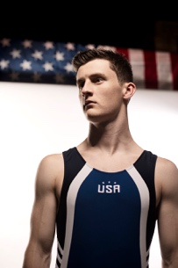
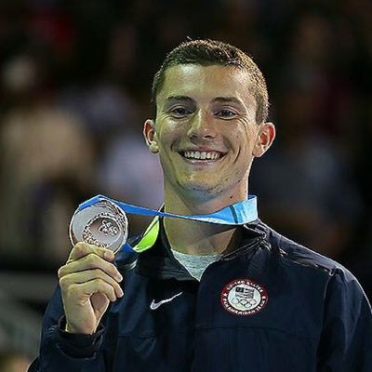

ATHLETE CLINIC REGISTRATION

Gym Name:__________________ Coach_______________________

Athlete Name: USAG #

Address:

City: State: Zip:

Gym Phone: _____________Cell Phone: ________________________

E-Mail: ____________________________________

Trampoline Level: DD of Optional Routine:

Most Difficult Skill:

Skill looking to learn at the clinic:

Cost of Athlete Clinic: $140.00 (3 Sessions)
Preferred sessions: ___________________________________
Each additional session: $30.00

NO REFUNDS!!!

Checks payable to: Elite Trampoline Academy
549 Route 35
Red Bank, NJ 07701
732-747-4000
Credit Card Option Payment:

Type of card________________

Card Number ______________________________

Expiration Date_____________ CVD Code________ Zip Code_______________

