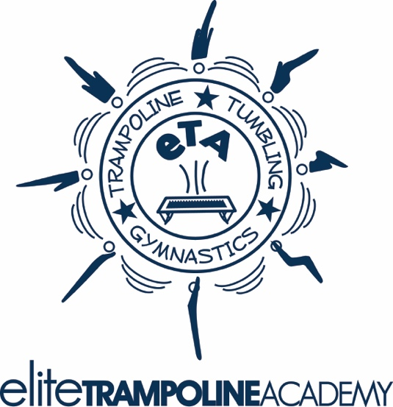
“Elite Performance” Clinic

at Elite Trampoline Academy
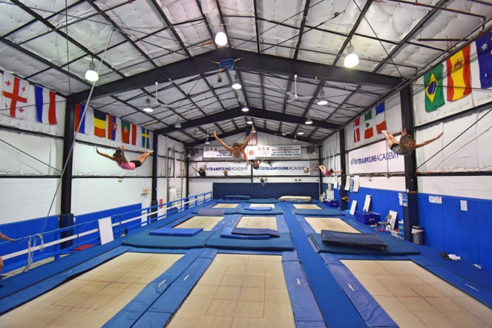

What
Athletes will work with World Champions and Olympians to learn and progress their trampoline, tumbling, & DMT skills and routines through drills, progressions, spotting, lessons in biomechanics, and routine building! Athletes will also better prepare for the upcoming National Championships one month later. Athletes will also receive insight on overcoming fears, blocks, and nerves competing in high pressure situations.
When
June 1-2, 2019
Saturday & Sunday

Where
Elite Trampoline Academy
549 Route 35
Middletown, NJ 07748
*40 miles from NYC*

Who
Athletes and Coaches of all levels

Clinicians
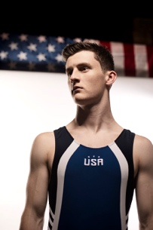
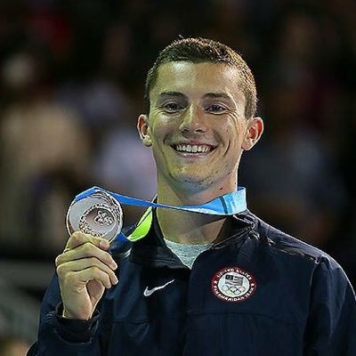

Jeffrey Gluckstein
6 Time USA National Champion
World Cup Silver Medalist
6x World Champ Team Member
Category 1 USA TR Judge
Steven Gluckstein
2012 Olympian
2016 Olympic Team Member
USA Jr. Nat’l Team Head Coach
10 Time USA National Champion
Category 1 USA TR Judge
Tatiana Kovaleva
1996, ’98, ’99 World Champion
1995 & 1997 European Champion
2012 Olympic Games USA Coach
USA National Coaching Staff
Category 1 FIG TR Judge

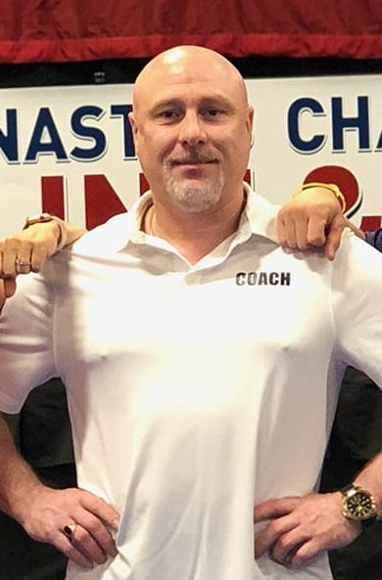
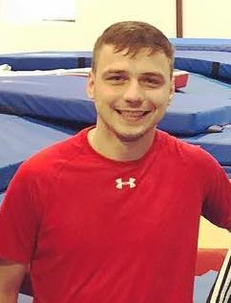

Slava Marozau
1992 World Champion
7x World Cup Champion
Cirque du Soleil “La Nouba” Performer
Misha Popov
Russian National Team Member
Coach of multiple US National Champions
Longtime performer for Ringling Brothers Circus

The “Elite Performance” Clinic is also a great learning experience for coaches to gain knowledge on progressions, drills, and helping athletes cope through fears and mental blocks (in training and also in competition).

Clinicians will also help you create a compulsory and/or optional routine for your Elite Athletes to optimize their total score for the 2018-2019 competition season.

Learn biomechanics on how to properly execute the trajectory and rotation of single, double, and twisting skills.

Above all, come work hard and get inspired to take your trampoline, tumbling, and DMT to the next level!

Saturday Sunday
Session 1 12:00-2:00 Session 5 9:00-11:00
Session 2 1:30-3:30 Session 6 10:30-12:30
Session 3 3:30-5:30 Session 7 12:30-2:30
Session 4 5:00-7:00 Session 8 2:00-4:00

Experience
The Jersey shore includes not only miles of
beautiful beaches but tons of attractions
such as rides & rollercoasters, aquariums,
and the best food your heart can desire!
Times Square, NYC is just a short 45 minute
Ferry ride away, which includes amazing views
of The Statue of Liberty, NYC, NJ, & Brooklyn
skylines.

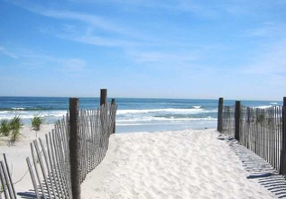
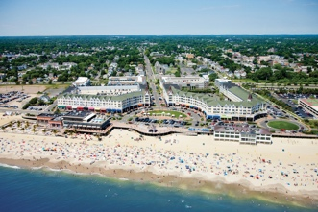

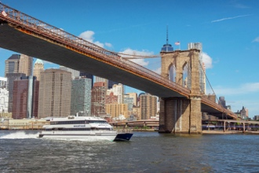
ATHLETE CLINIC REGISTRATION

Gym Name:__________________ Coach_______________________

Athlete Name: USAG #

Address:

City: State: Zip:

Gym Phone: _____________Cell Phone: ________________________

E-Mail: ____________________________________

Trampoline Level: DD of Optional Routine:

Most Difficult Skill:

Skill looking to learn at the clinic:

Cost of Athlete Clinic: $140.00 (3 Sessions)
Preferred sessions: ___________________________________
Each additional session: $30.00

NO REFUNDS!

Checks payable to: Elite Trampoline Academy
549 Route 35
Red Bank, NJ 07701
732-747-4000
Credit Card Option Payment:

Type of card________________

Card Number ______________________________

Expiration Date_____________ CVD Code________ Zip Code_______________

